Question : 1
Write a Python function bayes_posterior(prior, likelihood, evidence) that calculates and returns the posterior probability using Bayes theorem formula for given values :

def bayes_posterior(prior,likelihood,evidence):
posterior =(likelihood * prior) / evidence
return posterior
prior =0.20
likelihood =0.80
evidence =0.40
result =bayes_posterior(prior,likelihood,evidence)
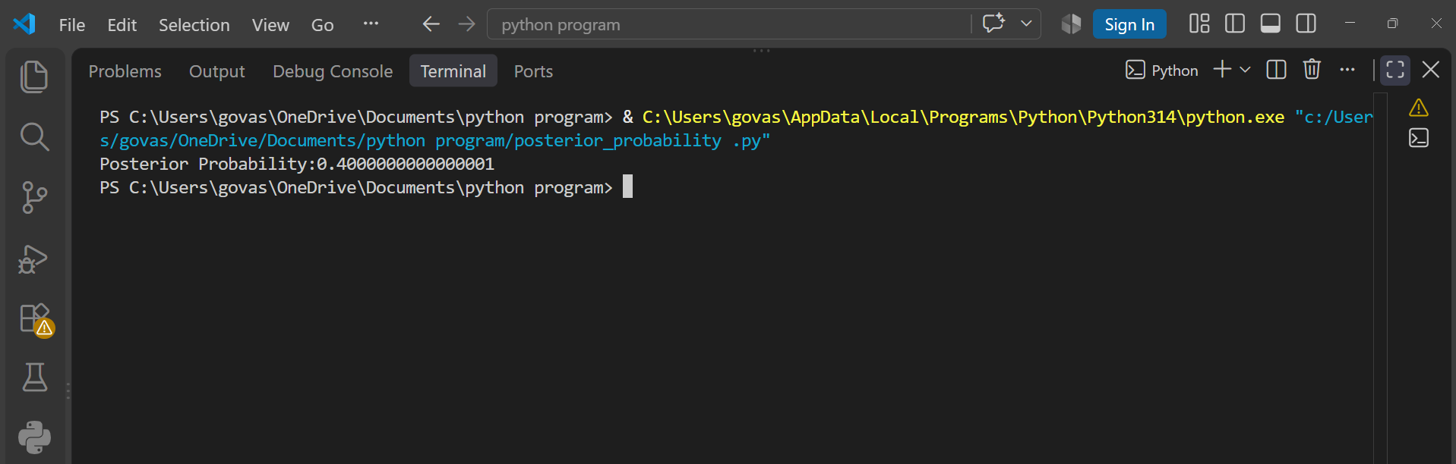
print(f"Posterior Probability:{result}")
The function successfully calculates the posterior probability using Bayes theorem. For the given values, the posterior probability is 0.4 or 40%.
Question : 2
Given the following scenario: On Swiggy, 10% of restaurants are 'premium', and 80% of premium restaurants offer a discount, while only 20% of regular restaurants do. If you see a discount, use Bayes theorem in code to find the probability that the restaurant is premium : <br><br><em><strong>Hint:</strong> Define prior, likelihood, and evidence in your code with comments.</em>

def bayes_posterior(prior,likelihood,evidence):
posterior =(likelihood * prior) / evidence
return posterior
# Prior probability of a restaurant being premium :
prior =0.10
# Probability that a premium restaurant offers a discount :
likelihood =0.80
# Probability that a regular restaurant offers a discount :
p_discount_regular =0.20
# Probability that a restaurant is regular :
p_regular = 1 - prior

evidence = (likelihood * prior) + (p_discount_regular * p_regular)
result =bayes_posterior(prior,likelihood,evidence)
print(f"Probability that the restaurant is premium:{result}")
print(f"Probability (%):", result * 100, "%")

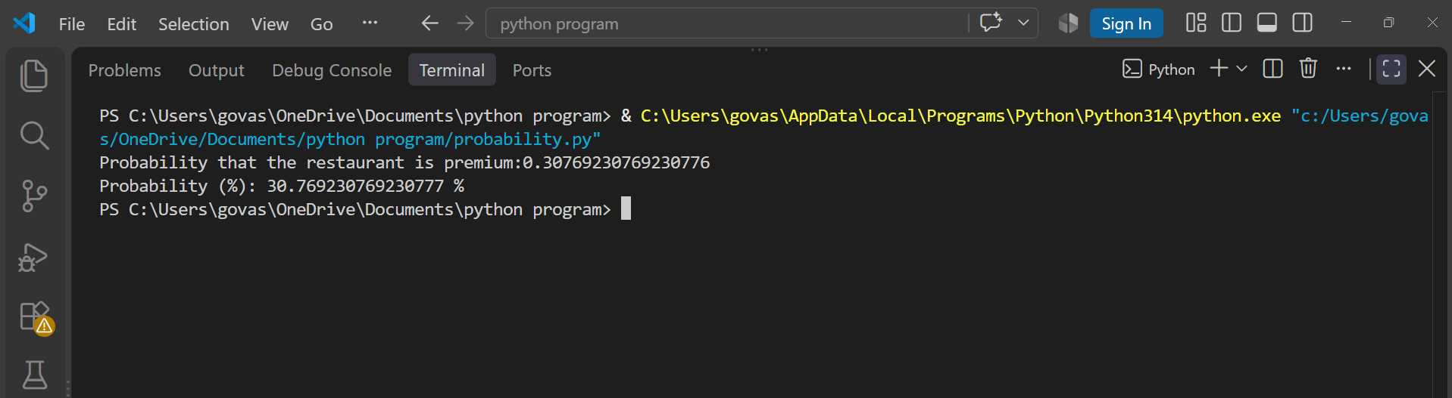
According to Bayes theorem, if a restaurant offers a discount, there is approximately a 30.77% probability that the restaurant is premium.

Question : 3
Simulate a basic spam detection filter: Given a list of 20 email subjects (some spam, some not), and the probability that 'free' appears in spam vs non-spam emails, write code to calculate the probability an email is spam if it contains 'free', using Bayes theorem :

def bayes_posterior(prior,likelihood,evidence):
posterior =(likelihood * prior) / evidence
return posterior

emails = [
"Win a free iPhone now",
"Meeting scheduled for tomorrow",
"Get free shopping vouchers",
"Your bank statement",
"Free gift waiting for you",
"Project meeting at 10 AM",
"Congratulations! You won free cash",
"Your order has been shipped",
"Claim your free reward",
"Monthly company newsletter",
"Free lottery ticket",
"Your electricity bill",
"Exclusive free offer",
"Team meeting reminder",
"You have won a free prize",
"Your Amazon order update",
"Free coupon available",
"Work from home meeting",
"Get free money today",
"Your account statement"
]

total_emails =len(emails)
spam_emails = 8
non_spam_emails = 12

prior_spam =spam_emails / total_emails
likelihood_free_spam = 0.75
likelihood_free_non_spam =0.10
prior_non_spam = non_spam_emails / total_emails
evidence = (
likelihood_free_spam * prior_spam
+ likelihood_free_non_spam * prior_non_spam
)
result =bayes_posterior(
prior_spam,
likelihood_free_spam,
evidence
)
print("Probability that the email is spam:", result)
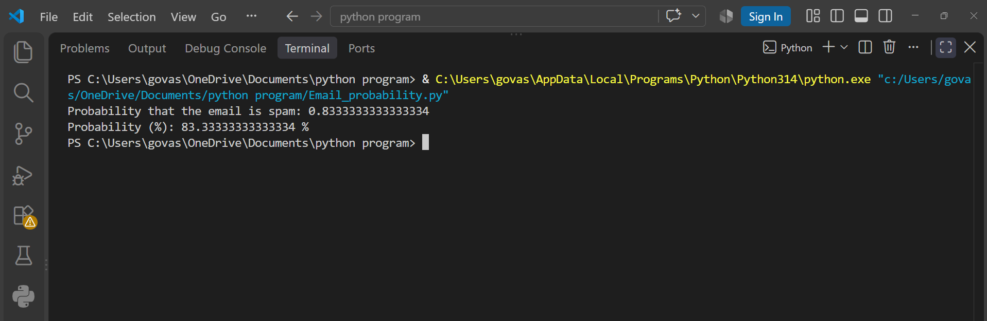
print("Probability (%):", result * 100, "%")
Using Bayes theorem, the probability that an email is spam when it contains the word "free" is approximately 83.33%. Therefore, an email containing "free" is highly likely to be spam based on the given probabilities.

Question : 4
Use ChatGPT or Copilot to generate a real-world Bayes theorem example related to any app you use (Instagram, Zomato, Flipkart, etc.), then write code to solve it and submit both the prompt you used and your code :
Give me a simple real-world Bayes theorem example related to Zomato.
Use an example where we want to find the probability that a restaurant
is highly rated if it offers a discount. Provide realistic probabilities
and explain the example simply.

def bayes_posterior(prior,likelihood,evidence):
posterior =(likelihood * prior) / evidence
return posterior
# Prior probability of a restaurant being highly rated :
prior = 0.30
# Probability that a highly rated restaurant offers a discount :
likelihood = 0.70
# Probability that a non-highly-rated restaurant offers a discount :
p_discount_not_rated = 0.25
# Probability that a restaurant is not highly rated :
p_not_rated = 1 - prior
# Total probability of getting a discount :
evidence = (
likelihood * prior
+ p_discount_not_rated * p_not_rated
)
# Calculate posterior probability :
result = bayes_posterior(prior,likelihood,evidence)
print("Probability that the restaurant is highly rated:", result)
print("Probability (%):", result * 100, "%")
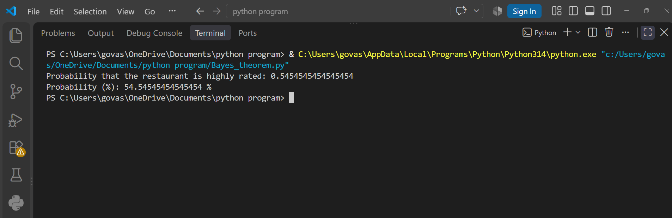

The probability that the restaurant is highly rated if it offers a discount is approximately 54.55% according to Bayes theorem.

